Calvary Baptist Ministries
P.O. Box 834
Eufaula, Oklahoma 74432
918-689-9403

Dear Parent: The following pages include:
- Information letter
- 2-page application
- Special Interview page
- Special Information page that needs to be “OK’d” by each item
- Medical History form that needs to be filled out completely. (If info. is not known, please put N/A by item.)
- “Consent” form that needs to be filled out and notarized.
- “Approximate Clothing Costs & Miscellaneous Needs” page
- Map from the Tulsa Airport to our ministry location
- Medical Physical form. Each resident is required to have a physical exam completed within the last 30 days. We will need the physical form returned to us, as well as the results of two blood tests; an “HIV” test, and a “Sexually Transmitted Disease” test. If you prefer, the physical exam and blood tests can be obtained here locally for about $50.00.
- “Goals for Achieving God’s Plan”. Please read this form. It will be filled out and completed at the time of the interview.
- Instructions for Interstate Compact. (Required for all out-of-state students)
- Interstate Compact form – Please fill out and bring to the interview
- Student Record Release Form (For Calvary Christian Academy)

Fill out each form completely and then bring them with you when you come for the interview.

Calvary Christian Academy requests that you bring all current school records. If your son has been home-schooled, please have your son’s grades in an “official” looking format. The courses should be listed giving: 1. Year taken, 2. Subject, and 3. Grade.

We will also need a letter from the boy’s dentist stating that he has had a checkup in the last 90 days. If a checkup has not been (or cannot be) obtained with your family dentist, we can help him get one here locally for about $20.00.

You will need to bring a copy of your son’s current immunization record.

We would appreciate your consideration of our dress policy while you come for the interview, as well as other visits to our grounds. This would include ladies wearing dresses/skirts & blouses and men wearing full length jeans/slacks and regular shirts. (No shorts or tank tops.)

Sincerely,

Bro. Tim Knight

PS: These forms were produced on Microsoft Word. If they do not print out properly, let me know.
Calvary Baptist Ministries
P.O. Box 834
Eufaula, Oklahoma 74432
918-689-9403

Dear Parent:

Thank you for your inquiry. Our ministry for boys, ages 13-18 yrs, which is called Calvary Christian Boarding Academy, has been in operation for over 37 years. We have been privileged to see hundreds of young men come through the program and end up becoming productive citizens.

As a Christian ministry we do not allow any alcoholic beverages, drugs or tobacco products. Our goal is to provide a quality Christian education that helps young men develop mentally, physically, as well as spiritually. We have an open-dormitory-type setting, which will house between 30-40 boys.

Each potential resident (and parent/guardian) is required to complete a 1-2 hour interview after which a decision will be made about acceptance. The young man will have to agree to abide by all of our rules, as well as stay a minimum of one year.

Our facility is on the south side of Hwy #150, which is located 5 miles north and ¾ miles west of Eufaula, Oklahoma. We trust this information is helpful. If you have any other questions or would like to contact us, feel free to call 918-689-9403.

Sincerely,

Bro. Tim Knight
Superintendent

Application for admission to
Please attach photo here

Calvary Christian Boarding Academy

Eufaula, Oklahoma

Please complete entire application

Application is being made for admission beginning __________________

Application is hereby made for the admission of: Social Security # __ __ __ __ __ __ __ __ __

- Name ________________________________________________________________ Age____________

- Date of Birth ______________U.S. Citizen(Yes/No)________Place of Birth ________________________

- Height_______________ Weight______________ Name which applicant prefers_____________________

- Name of father or guardian ________________________________________________________________
First Middle Last

A. Resident Address ________________________________________________________________

Street City State & Zip Code

B. Business Address _________________________________________________________________
Street City State & Zip Code

C. Occupation ______________________________________E-Mail ___________________________

Tel No. (____)______________________ (____)____________________ (____) _______________________
Area Code Home Area Code Business Area Code Cell

- Name of mother or guardian________________________________________________________________
First Middle Last

A. Resident Address ________________________________________________________________
(if other than 4-A) Street City State & Zip Code

B. Business Address _________________________________________________________________
Street City State & Zip Code

C. Occupation ______________________________________E-Mail ___________________________

Tel No. (____)______________________ (____)____________________ (____) _______________________
Area Code Home Area Code Business Area Code Cell

- In case of emergency contact (other then parent) _____________________ Phone_____________________

- Church affiliation of family________________________________ Is applicant a member (Yes/No) ______

Pastor’s Name ______________________________________ Phone _____________________________

- Are both of applicants parents living (Yes/No) __________

- Applicants brothers/sisters and their ages: ____________________________________________________

- Last school attended _____________________________________________________________________

A. Address _____________________________________________________________________________
Street City State Zip

Name of Principal or teacher ____________________________________________________________

- Was applicant honorably released (Yes/No) ______ Applicant’s current grade in school ____________

13.The quality of applicant’s schoolwork is ____ Excellent ____ Good ____ Fair ____ Poor (select one)

- Does applicant play musical/band instrument? (Yes/No) ______ If so, what kind? _________________

- List sports, hobbies or other activities in which applicant is interested:

Sports Hobbies Other Activities
____________________________ _____________________________ _____________________________

- Family activities applicant enjoys most: _____________________________________________________

17 List close relatives/guardians and describe the relationship to applicant: (example “Sue Jones - Sister – is very close to” or “Sarah Smith - Grandmother-lives in another state and seldom has contact with)
____________________ _________________________________________________________________
____________________ __________________________________________________________________
____________________ __________________________________________________________________
____________________ __________________________________________________________________
____________________ __________________________________________________________________
- Reason for applying to Boarding Academy and problems student has been having? (at school, home etc)
_________________________________________________________________________________________
_________________________________________________________________________________________
- Any Previous placements? (such as group homes etc, - including any Mental Health Facilities.) ______________________________________________________________________________________________________________________________________________________________________________

- Please use this space to describe why you feel your child would benefit from being a student at Calvary Christian Boarding Academy. ______________________________________________________________

AGREEMENTS PURSUANT TO THIS APPLICATION
Applicants are admitted only on the express condition that they shall remain at the school unless suspended or allowed to withdraw because of sustained illness. The parent or guardian agrees that in the event the student leaves the school no part of the fees already paid shall be refunded or remitted.
Calvary Christian Boarding Academy encourages parents to maintain contact with their son while at the academy. We recommend parents speak with their son on the phone each week, write at least once a week and come for a visit every month. (Parents from out of state are encouraged to visit as often as possible) Each student is required to write home once a week.
I agree to read the “Parent Handbook” that I have received. If I have any questions about the rules listed in the handbook I will contact the academy within 10 days to discuss my concerns. As a parent/guardian I agree to abide by all of the rules listed in the handbook and agree to support Calvary Christian Boarding Academy with my prayers.
I also agree to pay the monetary support of $__________________ per month for the boarding of this student and will make sure the academy receives the payment on or before the _________ day of each month.

Accepted: __________________________ Signature of Father/Guardian ____________________________
School Official

Date ________________________ Signature of Mother/Guardian ___________________________

Grievance Policy: Many students, not yet reaching their full level of maturity and character, are known to exaggerate circumstances including some incidents involving correction. If an individual has a problem with another student or a staff member, the incident in question should be brought to the attention of one of the senior staff, which includes Bro. Jerry McDonald, Jr, Bro. Tim Knight, Bro. Dale Collins, Bro. Fred Johnson, Bro. Cambrin Collins and Bro. David Bahre. Incidents will be checked out thoroughly and handled accordingly. All incidents determined to be a major problem will be taken to the director.
If a student wishes to file a grievance with the Academy office, a grievance form can be obtained from your personal staff counselor. Your parents will then be required to come to the academy within seven days to help resolve the issue.
Applicant must read policy and sign __________________________________

Calvary Baptist Ministries

Calvary Christian Boarding Academy

Eufaula, Oklahoma

---------------------------------------------------------------------------------------------------------

Parent's Name_____________________________________

Child's Name______________________________________

Date_____________________________________________

I hereby specifically direct that my child shall not be interviewed or questioned

by anyone outside the staff of the Calvary Baptist Ministries without my presence

and/or consent. I reserve the right to appoint a representative to act in my

stead if I am physically unable to be present for such interview or questioning.

I may be reached at the following telephone numbers, 24 hours per day, for

such purposes:

___________________________________

___________________________________

___________________________________

______________________
Parent's Signature

Special Information
Calvary Christian Boarding Academy

____ Letter Each student at the Academy will be required to turn in a letter each week as part of their English program. We will be working on penmanship, neatness and letter form. We need every parent to send us a list of people you would like for your son to receive letters from. The reason for this is that several have already mentioned that there are certain people that they do not want their son to correspond with. I think that this involved the wrong kind of friends and I personally think that this is a wise decision. Please send this list as soon as possible.

____ Students Personal Cash Because of comments made by several parents during orientation, we will sit up a special Student Bank. Several have commented that they feel that it would not be good for their son to carry cash. The Student Bank program will also work out good with our Academy program. The students will learn some real important lessons about keeping track of a checkbook.

____ Boarding Fees I have been asked if the boarding fees that you have agreed to pay to the Calvary Baptist Ministries is tax-deductible. I do not think so, but you may want to check with your tax-person.

____ Phone Calls Times for calling are listed in the Parent Handbook. Some parents have said that they would rather call than have their son call collect because it is cheaper for the parent to call. This is fine. It would be good for us to know when you choose to call so that your son will know when to be around the phone each week or whenever you call. Please limit calls to 10 minutes. We only have one phone line at the dorm.

____ Visitation Policy Calvary Christian Boarding Academy encourages parents to maintain contact with their student while he is at the Academy. We recommend parents speak with their son on the phone each week, write at least once a week and come for a visit every month or two. Each student is required to write home once a week.

____ Required Clothing All required clothing should be paid for by the parent/guardian upon enrollment. If later on extra clothes are needed, the Academy staff would be glad to pick up the clothes your son needs and bill you for them. This will include boots.

____ Fundraising Since we are a tuition free school and since we are keeping the boarding fee as low as we can possibly keep it, would you give the Academy permission to use your son to help with fund raisers? This would be strictly on a voluntary basis and the student would still be able to get the required amount of Paces done. No student that is behind in their work would be able to help with these programs during school hours.

____ Out of State Trips Occasional trips are taken to out-of-state locations for Basketball Games, Church Services, Gospel Concerts or Fund Raising, etc. These trips do not occur often; however, they may require a student to have extra money for personal expenses. If a student is eligible for a trip, he will be given advance notice of any extra financial need.
If you are in agreement with each of the subjects underlined, please place OK beside the underlined subject and sign below.

Parent’s Signature

Calvary Christian Boarding Academy
Students Medical History

Student’s Name __________________________ Sex ______ Race __________ Birth date _______

A. Family History

Family Member Birth date Cause/Date of Death Medical History
Father ________ _________________ ________________________________
Mother ________ _________________ ________________________________
Siblings: ________ _________________ ________________________________
____________ ________ _________________ ________________________________
____________ ________ _________________ ________________________________
____________ ________ _________________ ________________________________

B. Developmental History
gms cms
Birth Weight ______ lbs ______ oz; Length at birth ________ in. PKU: _________ Apgar: __________
Term of Pregnancy __________weeks; Delivery _______________________________________________
First tooth at _________ months; Sat alone at ________ months; Walked alone at ________ months
Talked at ______ months; Toilet trained at ______ months

C. Health History (Check any illness/condition the child has/had and indicate child’s age at onset, if known)
Whooping Couth _______________ Diphtheria ___________________ Diurnal Enuresis________________
Mumps ______________________ Otitis ________________________ Nocturnal Enuresis _____________
Measles (Rubeola) _____________ Convulsions __________________ Diarrhea ______________________
Rubella ______________________ Seizures _____________________ Constipation __________________
Chicken Pox __________________ Frequent Colds ________________ Irregular Sleep ________________
Scarlet Fever ________________ Asthma ______________________
Rheumatic Fever ______________ Hay Fever ____________________
Tonsillitis _____________________ Poor Appetite _________________
Growth regular? If no, explain: ______________________________________________________________
Sudden/unexplained weight loss/gain? If yes, explain ____________________________________________
Operations, accidents, injuries: ______________________________________________________________
Allergies _________________________________________; Blood Group ________ RH Factor __________

D. Immunizations and Tests

Vaccine Date Date Date Test Date Result Date Result

DPT ______________________________ Audiometer _____________________________
DPT Booster _______________________________ Vision _____________________________
DT ______________________________ Tuberculin _____________________________
Tetanus Only ______________________________ VDRL _____________________________
Polio – OPV ______________________________ Sickle Cell _____________________________
Rubella ______________________________
Rubeola ______________________________
Mumps

E. Behavior _____________________________________________________________________________

F. Care Instructions
Feeding ___________________________________________________________________________
Medication _________________________________________________________________________

Prepared by ________________________________________ Date ___________ County ______________

STATE OF ___________________

COUNTY OF _________________

CONSENT OF PARENT OR GUARDIAN

I, ____________________________________________, as parent or legal guardian for _________________________________________, do hereby agree to the following:

I agree that I will hold harmless and not bring suit against Calvary Baptist Ministries and its ministries, or its agents or employees for any injury, harm or other dangers whether caused by its agents, employees, or by third parties, nor will any action be brought for the acts of the child named above.

This consent authorizes the use of pictures of said child for the promotion of Calvary Baptist Ministries.

This consent also authorizes the release of school information pertaining to said child to Calvary Baptist Ministries for its private use and evaluation.

I further consent that the authorities of Calvary Baptist Ministries may provide for examination and/or diagnostic procedures and may provide emergency surgery, counseling services and/or medical or dental treatment or administration of necessary anesthetics, when in the opinion of any physician or surgeon of good standing such examination, diagnostic procedures, emergency surgery, administration of anesthetics or medical treatment is necessary for the mental or physical health of said child.

Furthermore, I hereby assume full responsibility for the total cost of any emergency, medical or dental needs listed above. Also, I give my permission for the additional dispensing of medicines, prescribed or otherwise needed, as the school deems necessary.

_________________________________
Signature of parent/guardian

_________________________________
Date
Sworn To and Subscribed Before Me,
This the ___ Day of _______, 20_______ _________________________________
Notary

Clothing & Miscellaneous Needs

(These costs are approximate and

does not include sales tax or recent cost increases.)

Clothing

2 Pair of slacks @ $32.99 each------------------------------- $ 66.00
(100% Polyester Blue “Wrancher” Wrangler brand western Slacks)
2 Blue “Polo” type shirts with collars @ $10.00 each---- 20.00
(Available at Academy)
2 Red “Polo” type shirts with collars @ $10.00 each----- 20.00
(Available at Academy)
1 Tie for Chapel------------------------------------------------- 10.00
1 Western Belt and Buckle------------------------------------ 20.00
1 Pair of Western Boots--------------------------------------- 89.99
(must be Black pull-on type, no lace up boots)

Miscellaneous

Medical Physical------------------------------------------------ $ 50.00
(Must be a complete physical exam and two blood tests, using form obtained from the Academy)
Dental Checkup ------------------------------------------------ 20.00
Foot Locker------------------------------------------------------ 23.00
Approximate Costs------------------------------- $ 318.99

Additional Items Needed

1 Pair (minimum) of “Slicks” for gymnasium (also called “wind pants”)

1 Pair of Tennis shoes for the Basketball court
5 Pairs (minimum) of crew or tube socks (no ankle socks)
5 pairs (minimum) of briefs (full cut) or boxer shorts
3 pairs (minimum) of Blue jeans - should be boot cut or western cut
(no acid washed or stonewashed)
T-shirts and/or pullover shirts for work and free time
Tennis shoes or work boots for free time
Personal items such as toothbrush, toothpaste, deodorant,
comb, writing paper and envelopes, pen and pencils
Personal spending money - around $25.00 per month
King James Version Bible

Directions to

Calvary Baptist Ministries

Eufaula, Oklahoma 74432

918-689-9403

From Tulsa Airport - Take Hwy 11 East, to Hwy 169 South, to Hwy 51 East, to Hwy 69 South, to Hwy 150 West, ¾ of a mile. Calvary Baptist Ministries is located on the south side of the road.

From Oklahoma City Airport – Go North on Meridian Ave to I-40, east on I-40 about 120 miles to Hwy 69, go south 7 miles to Hwy 150, then go west ¾ of a mile. Calvary Baptist Ministries is located on the south side of the road.

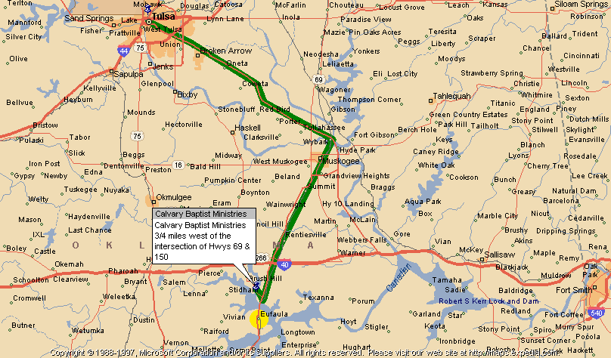

DATE OF EXAM _______________________

Report of Physical Examination

Student’s Name _______________________________________ Birthdate ________________________

Height
Weight
Temperature
Blood Pressure
Presenting Complaint, if any
Head Measurement of Infant
Skin
Scalp
Eyes - | Vision w/o Glasses | Rt. Lft.
 | Vision w/ Glasses | Rt. Lft.
 | Pupillary Reaction
 | Eyegrounds
 | Other
Ears - | Otoscopic
 | Hearing | Rt. Lft.
 | Other
Nose
Teeth - | Number
 | Condition
 | Occlusion
 | Other
Throat - | Pharynx
 | Tonsils
Adenoids
Glands
Thyroid
Chest
Heart
Lungs
Abdomen
Secondary Sex Characteristics
Genitals
Menstrual History Since Last Visit (Adolescent Girls)
Deep Reflexes
Superficial Reflexes
Extremities
Feet
Spine
Posture
Nutrition
Signs of Endocrine Imbalance
Signs of Vasomotor Instability
Other
UA - | Color, Reaction, Sp. G.
 | Sugar, Albumin, Micros.
Blood Hemoglobin, Count, etc.
Other Tests
Impressions and Advice
Physician’s
Signature

Goals for Achieving God’s Plan ____________________

Student’s Name
The desire of Calvary Christian Boarding Academy is to provide a Christian environment that nurtures Christian values such as: respect for authority, Christian manhood, Biblical self-image and Christian service.
This form lists the “goals” that will be pursued to help this individual develop to his fullest academic, physical and spiritual potential. Also listed is how these goals will be implemented.

1. Education: Each student will attend Calvary Christian Academy, a K -12th grade private Christian school. New students will be given diagnostic tests. The results of these tests, plus a review of any previous school’s records, will determine the courses that a student will take. Each person will be challenged to develop to his fullest potential.

2. Learning Responsibility: The Academy uses the Scriptural principle of “whatsoever thy hand findeth to do, do it with thy might”. Whether in the classroom or out, on the basketball court or during housekeeping chores, each student is taught to take responsibility for the task at hand and to do it properly.

3. Provide Food/Shelter: All students are housed in an open-dormitory setting which includes clean restroom and bathing facilities. Nutritious breakfast, lunch and dinner meals are served in the dining room along with an evening snack.

4. Religious: All students attend Calvary Baptist Church, on which grounds the Academy is located. Regular Sunday and Wednesday night services are conducted as well as various revival and camp meetings that each student attends. Morning and evening devotions are also held, as well as Scriptural teaching in the Christian school.

5. Special Needs: The Academy strives to work with students and their particular needs. These range from extra reading programs, individualized school curriculum and “one on one” assistance from the teachers and academy staff inside the classroom. We can also accommodate some special physical needs such as “asthma” inhalers, diet restrictions or trips to dental professionals for help with braces, etc. Each special need must be discussed with the Academy staff prior to acceptance.
Goals needed to achieve for completion: (Goals for Discharge)

1 Scriptural Values are becoming evident.

(Romans 14:1; Micah 6:8; I Corinthians 6:9-12, 19-20; I Corinthians 16:13-14)

2. Academic Progress – He will be enrolled in Calvary Christian Academy, which emphasizes diagnostic testing, individualized instruction, high academics and Biblical standards of values and dress.

3. Length of Stay - He may be encouraged to stay longer than one year, if necessary.

4. Specific needs to be addressed: _____________________________________________________________ __________________________________________________________________________________________________________________________________________________________________________________ While here at Calvary, he will be required to attend school regularly and complete normal amounts of course work each week. He will receive counseling to help him see the need for a high school education. He will also receive help on acting responsibly, learning to do what he is told, as well as helping instill Christian character in his life.

5. Plans for student after leaving the Academy – The goal is for this student to return home after leaving the Academy.

6. Parent Acknowledgement - I have discussed my son’s needs with the staff and have participated in this "Goals For Achieving God’s Plan”

Parent/Guardian __________________________Student ___________________________
School Official ___________________________ Date _____________________________

Calvary Christian Boarding Academy

For Parents that live Out-of-State

Dear Parent: Please read and fill in the following information.

For over 30 years there have been agencies in each state that oversee the placement of children that go from one state to another. This was designed to insure that the needs of these young people would be taken care of when they move outside of their home state. This is called, “The Interstate Compact on the Placement of Children”.

Only recently has this applied to boarding academies such as ours. In order for a parent to place a boy in our ministry, a one-page form needs to be filled out and submitted to the Interstate Compact Office - both in the state that you live in as well as in Oklahoma. The process is not complicated and we have filled out some of the one-page form that is enclosed with this email. We need you to fill in the following areas in the accompanying page.

Section I (Fill in ONLY the items mentioned below) Leave other areas BLANK.

Line One - Write or type your son’s name.
Line One, right hand section – Place “X” on Origin (Nationality)
Line Two – Write or type Social Security number
Line Three - Write or type Date of Birth
Line Four – Write or type Mother and Father’s name
Line Five – Write or type whichever parent is most responsible for child and phone #.
Line Six – Write or type Parent’s address

Section III (Fill in ONLY items mentioned below.) Leave other areas BLANK.
Line Two – Write or type name of parent responsible (as is Line Five above).
Line Four – Parents needs to SIGN here and put current date.

After the interview is conducted here at the academy and your son is accepted, we will send in the .proper forms. If you have any questions, feel free to contact us.

Sincerely,

Bro. Tim Knight
Superintendent

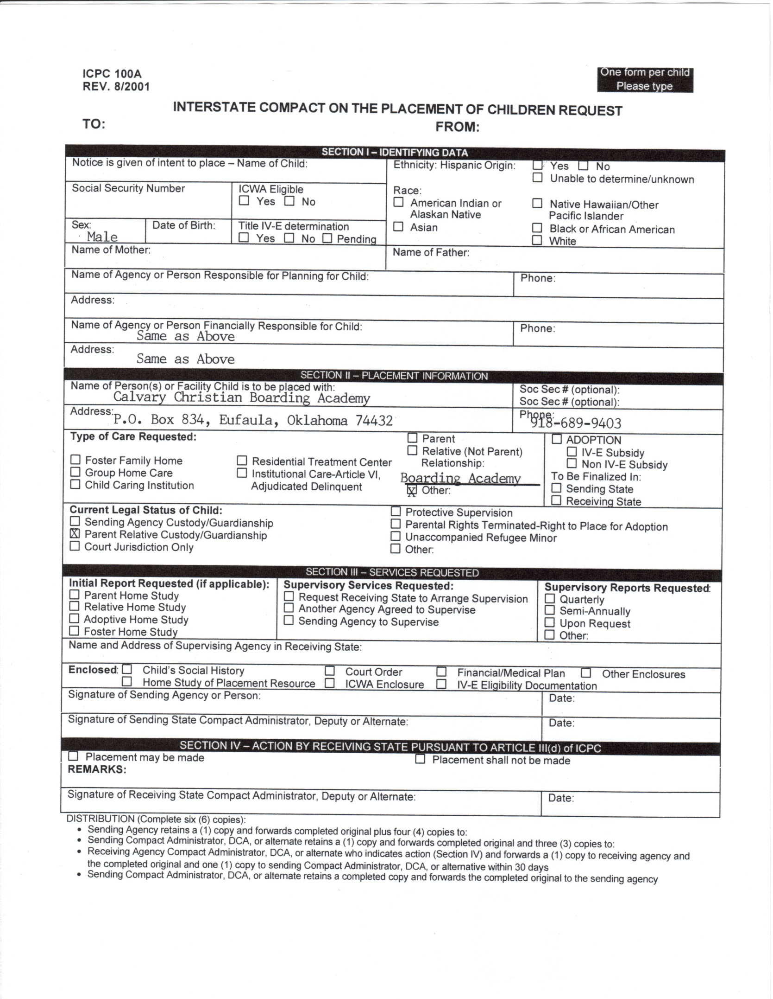
STUDENT RECORD RELEASE

RELEASING SCHOOL |  | RECEIVING SCHOOL
 |  | Calvary Christian Academy
School |  | School
 |  | P.O. Box 834
Address |  | Address
 |  | Eufaula OK 74432
City State Zip |  | City State Zip
_______________________________  Date |  | School Phone 918-689-9403  School Fax 918-689-4789

Dear Counselor:

Please release the academic, health and medical records of students listed below to the above name receiving school. Also, if available, psychological evaluations and behavioral reports, as well as standard test results.

Thank you very much.

STUDENT’S NAME  (Last name first) | AGE | GRADE LEVEL AT TIME  OF WITHDRAWL

THANK YOU,

_________________________________
Signature of Parent/Guardian

_________________________________
Signature of School Official

