GROWING IN GOD’S WORD CORNERSTONE
“Stand fast therefore in the liberty wherewith BAPTIST CHURCH
Christ hath made us free, and be not entangled
again with the yoke of bondage.” 5434 7th Street
Galatians 5:1 Zephyrhills, FL 33542
813-783-2727
cornerstonebczhills.org

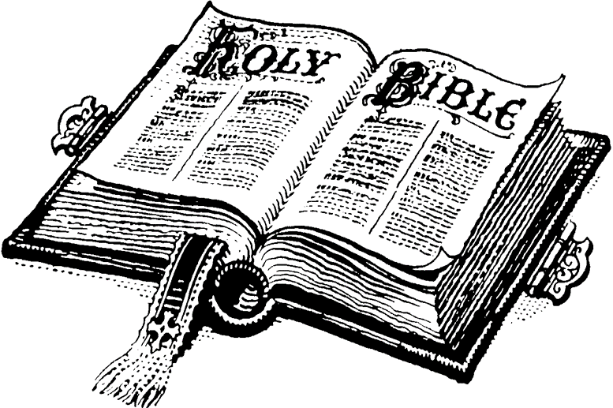
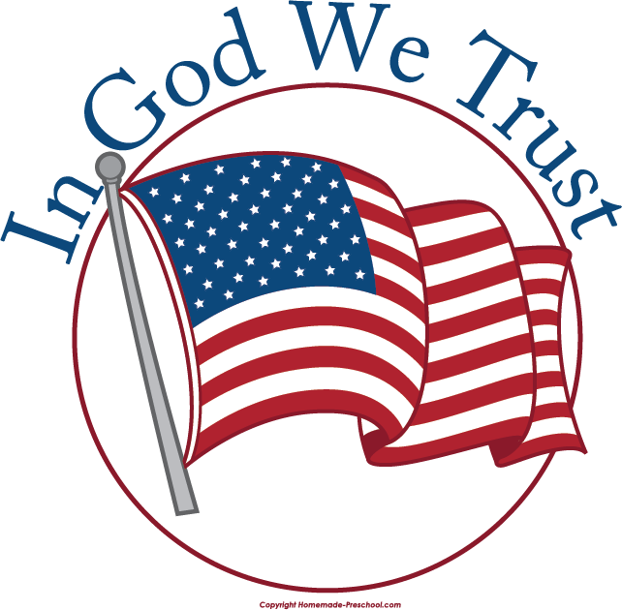

PRAY FOR AMERICA “…Jesus Christ himself being the chief corner stone…”
Ephesians 2:20
“If my people, which are called by my name,
shall humble themselves and pray, and seek
my face, and turn from their wicked ways;
then will I hear from heaven and will forgive
their sin and will heal their land.” Stephen R. Lamb, Pastor
II Chronicles 7:14 910-389-0762

July 4, 2021

The End of Your Search for an Old-Fashioned Bible Centered Church

