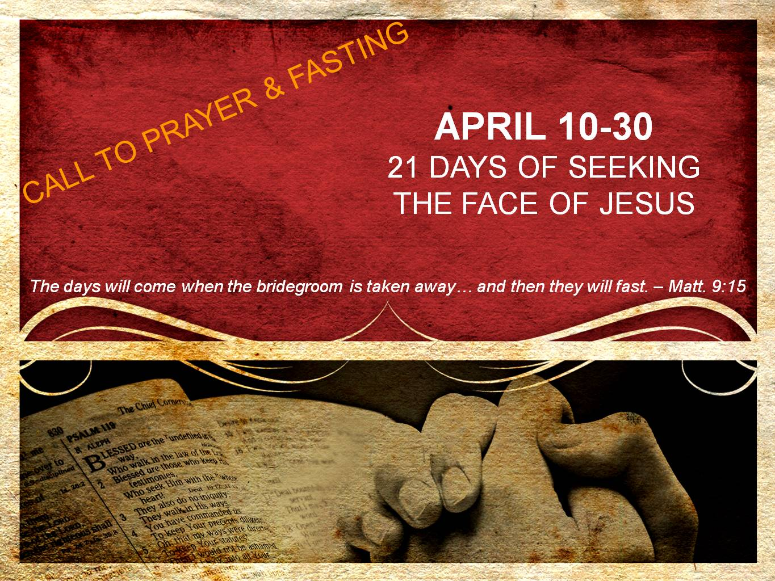
DAY 8
Humility before the Bridegroom
“He who has the bride is the bridegroom; but the friend of the bridegroom, who stands and hears him, rejoices greatly because of the bridegroom’s voice. So this joy of mine has been made full. He must increase, but I must decrease.” – John 3:29-30

The joy of the Lord leads to humility before the Lord.

What type of outrageous statement is this? Joy leading to humility? Yet, is this not what John is stating here in this passage?

It is within the context of John’s joy being full that he makes the confession that Jesus must increase but he must decrease. Let us meditate on the revelation of the joy of the Lord which leads to humility before the Lord.

As we stand with our Bridegroom & hear His voice, our joy becomes full because we are in the presence of the One who states that “in His presence is fullness of joy.” This fullness of joy is more than a mere emotion. Rather, it is birthed from the Holy Spirit within us as we have a revelation of who Jesus is and what He has done for us. Upon this revelation of who He is and what He has done, joy arises as we become completely satisfied in Him. This satisfaction in Christ then frees us to surrender all our titles, positions, & reputations in ministry. It is from this place of joy & freedom in Christ that we can gladly bow our hearts before Jesus, declaring, “He must increase, but I must decrease.”

What an amazing revelation - the joy of the Lord leading us into humility before the Lord.

Prayer
Jesus, teach me that humility is not misery. Rather, humility is found as I am fully satisfied in You. As John, this may cause my ministry and reputation to fade as You become more and more famous. However, because I am fully satisfied in Your presence and full of joy as I hear Your voice, I gladly allow all of my life and ministry to point to You. You must increase Jesus. I must decrease. I am humbled before You today as I have found fullness of joy in You. I love You, Jesus! Amen.

