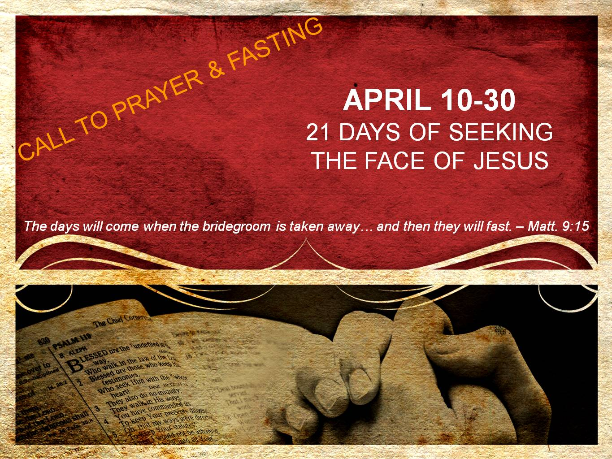
DAY 9
Freedom
“Is this not the fast which I choose, to loosen the bonds of wickedness, to undo the bands of the yoke, and to let the oppressed go free and break every yoke?” – Isaiah 58:6

Isaiah 58:5-12 gives a wonderful picture of God’s chosen fast. As one might expect, this chosen fast begins with humility (Isaiah 58:5). We meditated on humility yesterday - therefore today we will examine the promise of freedom in Isaiah 58:6.

Freedom is a word used often, however what does it specifically mean in the context of fasting?

First and foremost, we must be struck with the reality that we cannot continue in sin and hope that our fasting will earn us favor with God. God does not desire our sacrifice of fasting – He desires obedience. We find favor with God in the blood of Christ alone as we abide in Him. Our fasting is to draw us closer to God as we deny the flesh and put our wicked ways behind us. Let us not tolerate any willful, unrepentant sin in our life.

Second, fasting releases a power to overcome strongholds of sin and the demonic. When Jesus’ disciples asked Him why they could not cast out the demon from the boy, Jesus replied, “This kind does not go out except by prayer and fasting” (Matthew 17:21).

As we fast, we will discover an increase to overcome sin in our own lives, as well as power to minister deliverance to others. Again, this is not because we have earned something from God, but rather we are denying our flesh and submitting to the Holy Spirit, allowing us to be more in tune with His leading.

In humility we stand with our Bridegroom, hearing His voice. He is calling to us that now is the time of freedom from sin! It is a call to the repentant life.

Prayer
Jesus, I repent from every willful, unrepentant sin in my life. I ask for you to forgive Me in Your great mercy and extend a grace to walk in freedom. In the midst of this fast, I also ask for You to show me areas in my life that are outside of Your will. Replace every lie with Your truth and deliver me from every demonic influence in my life. I long to be completely aligned with Your perfect will and free from all bonds of wickedness and every yoke of oppression. Set me free, Jesus!
I also ask today that I would have Your heart for Your creation - that I would not be found guilty of placing any undue yokes upon others, and that You would grant me a grace to see others set free by the power of the Holy Spirit.
I love You, Jesus! Amen.

