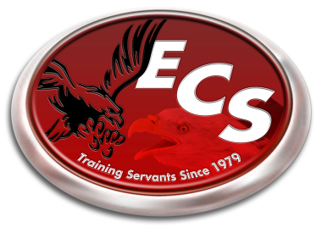
ECS 2015-2016 School Calendar

August 3rd-6th - Teacher Work Week
August 6th - Teacher/Parent Meeting – 6:00 pm
August 7th - First Day of School
September 7th - Labor Day Holiday
October 6th - School Portraits
October 9th - End of First Quarter
October 16th - Teacher Training in TN.
November 23rd-27th - Fall Break
December 18th - End of Second Quarter
Dec. 21st-Jan. 1st - Christmas Break
January 4th - School Resumes
January 18th - Martin Luther King Jr. Holiday
February 15th - President’s Day Holiday
March 4th - End of Third Quarter
March 7th-11th - Spring Break
March 28th – March 31st - Standardized Testing Week
(school out at 12 pm each day)
April 8th - Sports Banquet
May 3rd - Awards Banquet (6 pm)
May 6th - Kindergarten Graduation (6 pm)
May 13th - Last Day of School
High School Graduation (6 pm)

*Underlined Dates denotes “No School”
*Schedule is tentative and subject to change is something arises that would cause it to.

