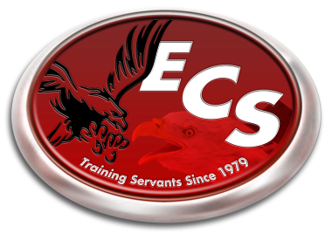
ECS 2014-2015 School Calendar

August 4th-7th - Teacher Work Week
August 7th - Teacher/Parent Meeting – 6:00 pm
August 8th - First Day of School
September 1 - Labor Day Holiday
October 7th - School Portraits
October 10th - End of First Quarter
October 17th - Teacher Training in TN.
November 24th-28th - Fall Break
December 19th - End of Second Quarter
Dec. 22nd-Jan. 2nd - Christmas Break
January 5th - School Resumes
January 19th - Martin Luther King Jr. Holiday
February 16th - President’s Day Holiday
March 6th - End of Third Quarter
March 9th-13th - Spring Break
March 31st – April 2nd - SAT Testing Week
(school out at 12 pm each day)
April 3rd - Good Friday Holiday
May 5th - Awards Banquet (6 pm)
May 8th - Kindergarten Graduation (7 pm)
May 15th - Last Day of School
High School Graduation (7 pm)

*Underlined Dates denotes “No School”
*Schedule is tentative and subject to change is something arises that would cause it to.

