REVIVAL
Maranatha Baptist Church
September 9 – 14, 2012
Sunday – 11am & 6:30pm
Monday – Friday – 7:00pm
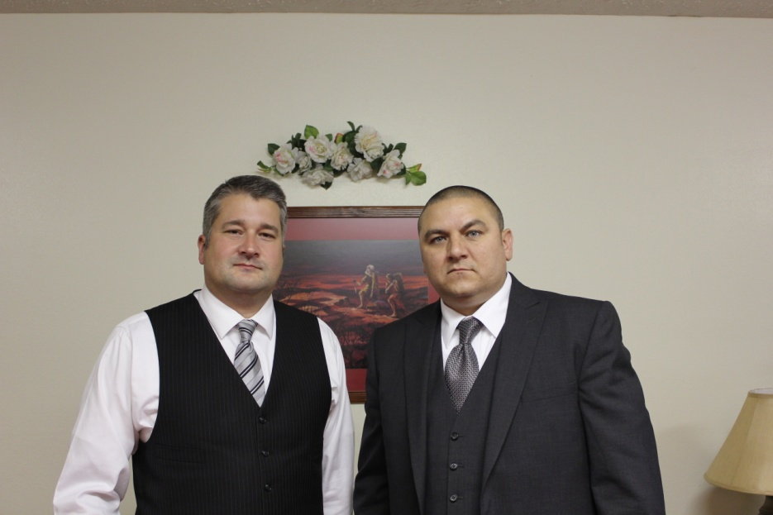
Dale Vance, Sun-Wed
Barry Spears, Thurs-Fri
Visit our website: www.mbcwva.com
REVIVAL
Maranatha Baptist Church
September 9 – 14, 2012
Sunday – 11am & 6:30pm
Monday – Friday – 7:00pm
Dale Vance, Sun-Wed
Barry Spears, Thurs-Fri
Visit our website: www.mbcwva.com

