Four Horsemen of the Apocalypse
Revelation 6:1-8

This is a symbolic vision of the Antichrist as he proceeds through the
7 years of Tribulation.

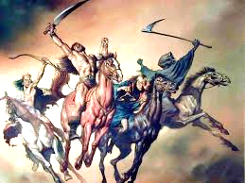
Death and Hell are paired here on the pale horse. This unwelcomed rider can be followed through the remainder of the Book of Revelation. If this rider appeared today, he would take more than 1.5 billion souls!
DEATH & HELL
FAMINE
Food shortages naturally follow war. Regimentation of resources is implemented by the Antichrist.
WAR
‘PEACE’
Antichrist is now exposed as a blood-thirsty warlord. World domination is his agenda. Notice: the rider now has a weapon…a sword!
Antichrist appears on the world stage with a plan for ‘peace’
(bow with no arrows)

