“Times of the Gentiles”
Daniel 2:31-45
Nebuchadnezzar’s Dream
Crucial to an understanding
of the Judgment of the Gentiles
Luke 21:24
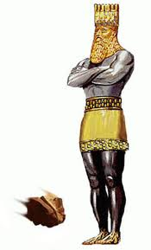
FEDERATION of NATIONS
(revived Roman Empire)

BABYLON
KING of KINGS at His SECOND COMING To put down Gentile rule and establish His everlasting Kingdom of Righteousness

ROME

GREECE

MEDO-PERSIA

“And the seventh angel sounded; and there were great voices in heaven, saying, The kingdoms of this world are become the kingdoms of our Lord, and of his Christ; and he shall reign for ever and ever.”
Revelation 11:15

