The Judgment of the Gentiles
Sheep & Goat Judgment
Matthew 25:31-46

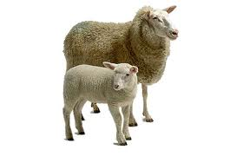

To aid a Jew during the reign of
Antichrist is to risk one’s life.

- Those Gentiles that HAVE shown compassion toward the Jews during the 7 years of Tribulation and especially during the last 3 ½ years known as “Great Tribulation”
- These Gentiles will have refused the ‘Mark of the Beast’ and defied
the ‘man of sin’
- ADMITTED INTO THE KINGDOM
Keys to Understanding this Judgment
- This is NOT the Judgment Seat of Christ (for believers)
- This is NOT the Great White Throne Judgment (for unbelievers)
- This is NOT a judgment of works--this IS a judgment of faith
the works of the sheep merely evidence their faith (‘faith without works is dead’)
- This Judgment occurs on Earth AFTER Tribulation and BEFORE the Millennial Kingdom


BLESSED
CURSED
- Those Gentiles that have shown NO compassion toward the Jews during the 7 years of Tribulation and especially during the last 3 ½ years known as “Great Tribulation”
- These Gentiles will have already taken the ‘Mark of the Beast’ and align themselves with the ‘man of sin’
- CAST INTO ‘EVERLASTING FIRE’

